Dear Dr. Shinbrot,

It is my pleasure to submit for your consideration our new manuscript, entitled “Machine learning for predictive estimation of qubit dynamics subject to dephasing” for consideration in Physical Review Applied. This work, like our previous publication in Physical Review Applied, addresses the key challenge of dynamic control in quantum systems for technological applications.

Decoherence – and dephasing in particular – is a major challenge in most technological applications of quantum coherent systems. Control engineering techniques and machine learning promise new advances in how we can compensate for this unwanted system evolution. However their application in quantum systems has seen only limited study to date because the mapping of quantum dynamics to established formalisms is challenging. The question of which of a large and growing set of machine learning algorithms is best deployed for problems in quantum control therefore requires addressing.

In this work we combine insights from multiple disciplines, including quantum physics, information theory, control engineering, and computer science, in order to study the problem of predictive control for qubits subject to a common form of decoherence. We explore how algorithms such as Kalman filtering and Gaussian Process Regression (GPR) can be used to learn about the apparently random behaviour of qubits subject to dephasing and then employ that knowledge to predict future evolution of the qubit state.

In this study, we develop and explore a broad class of predictive estimation algorithms allowing us to track a qubit state undergoing stochastic but temporally correlated evolution using a record of projective measurements, and forecast its future evolution. Our approaches employ machine learning algorithms to extract temporal correlations from the measurement record and use this information to build an effective dynamical model of the system's evolution. We design a protocol to correlate Markovian processes such that a certain general class of non-Markovian dynamics can be tracked without violating the assumptions of the underlying machine learning protocol. Both algorithmic frameworks we employ provide a mechanism by which temporal correlations are encoded into the algorithm's structure such that projection of data-sets onto this structure enables meaningful learning, reduction of the impact of measurement-noise, and effective forward prediction.

We perform numerical simulations to test and compare the effectiveness of these algorithms in maximizing the prediction horizon under various conditions, and quantify the role of the measurement sampling rate relative to the noise dynamics in defining the prediction horizon. Simulations incorporate a variety of measurement models, including pre-processed data yielding a continuous measurement outcome and discretised outcomes commonly associated with single-shot projective qubit measurements. We find that in most circumstances an autoregressive Kalman framework yields the best performance, providing model-robust forward prediction horizons and effective filtering of measurement noise. Finally, we demonstrate that standard GPR-based protocols employing a variety of kernels, while effective for the problem of filtering (fitting) a measurement record, are not suitable for real-time forecasting beyond the measurement record.

Our study performs some of the first detailed insights into the performance of machine learning algorithms that are well established in classical control, for quantum systems. Given the rapid growth in investment from major corporates in quantum information, and the growing importance of adapting engineering techniques in quantum technology, we believe that this work is timely and makes a vital and substantial contribution to the field. We look forward to working with you towards its publication in Physical Review Applied.

Best regards,
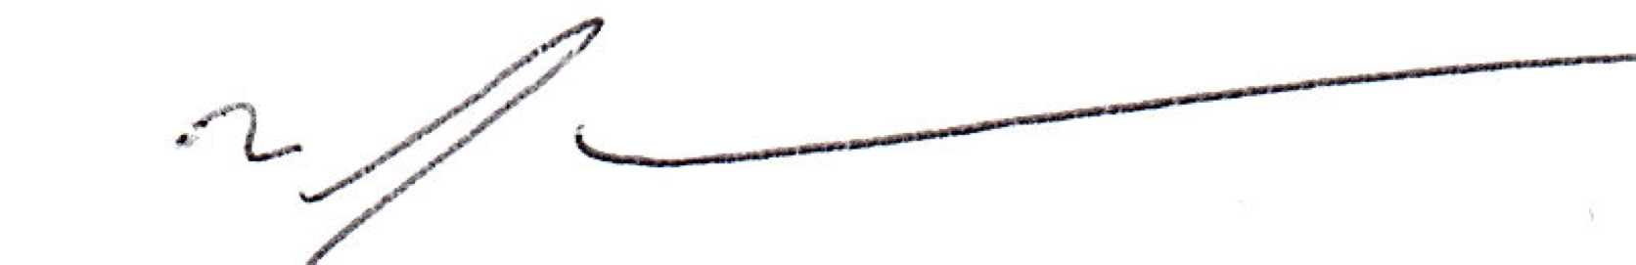

Michael J. Biercuk

